МИНИСТЕРСТВО ОБРАЗОВАНИЯ И НАУКИ

РОССИЙСКОЙ ФЕДЕРАЦИИ

ФЕДЕРАЛЬНОЕ ГОСУДАРСТВЕННОЕ АВТОНОМНОЕ

ОБРАЗОВАТЕЛЬНОЕ УЧРЕЖДЕНИЕ ВЫСШЕГО ОБРАЗОВАНИЯ

«САМАРСКИЙ НАЦИОНАЛЬНЫЙ ИССЛЕДОВАТЕЛЬСКИЙ

УНИВЕРСИТЕТ ИМЕНИ АКАДЕМИКА С.П. КОРОЛЕВА»

Кафедра геоинформатики и информационной безопасности

ЛАБОРАТОРНАЯ РАБОТА №1

Тема: **«VM and RAID»**

Выполнил:

студент группы 6412

Денисов П.В.

Самара 2023

**Task**

Steps:

1. Create virtual machine with debian/ubuntu/centos or download preinstalled image (<https://www.osboxes.org/>). It should be withoug GUI.
2. Set hostname = your surname.
3. Add simple raid1 to virtual machine: *nix os system on 1-st hdd, 2d and 3d hdds are in raid1. 1 (with star). Only two hdds. Os system on raid1, based on this two hdd.
4. How to test raid1. Create file on raid1 file system. Turn off vm and remove one of the hhds from vm. Turn on vm. File should be accessible.
5. Add new hdd and sync it to raid1.
6. Install and run local Kubernetes cluster with **minikube**

* Use steps from Kubernetes install Tools <https://kubernetes.io/docs/tasks/tools/> Make report with screens of:
* minicube version command output
* opened Dashboard in your web-browser
* web-abblication in your web-browser (<http://localhost:7080/> in tutorial)

1. Deploy hello-minikube app
2. Create Assignment1 report and send it by e-mail (docx/link to google doc) or through creation repo fork + pull request.

Using an Ubuntu 22.04 virtual machine using VirtualBox and adding two additional HDDs to the VM:

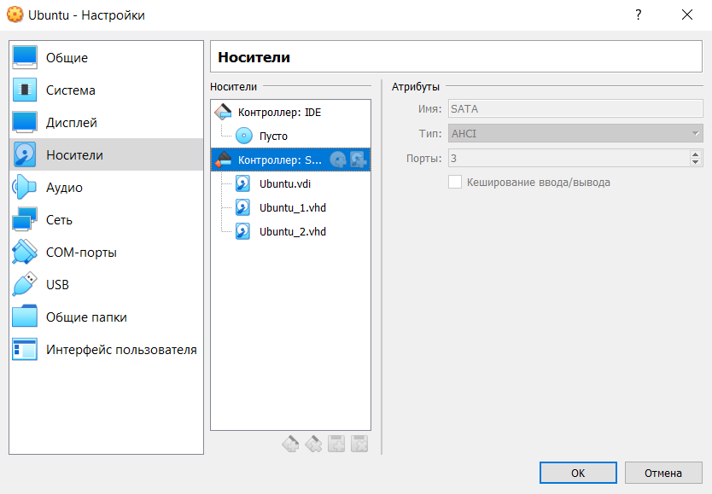

View all virtual machine disks using the lsblk command:

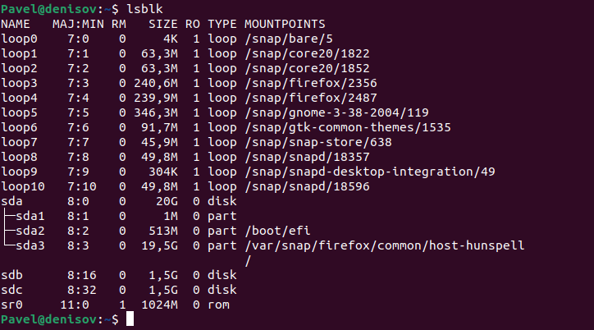

Creating RAID 1 based on sdb and sdc, for which we will initially create sdb1, sdc1 partitions using the fdisk command.

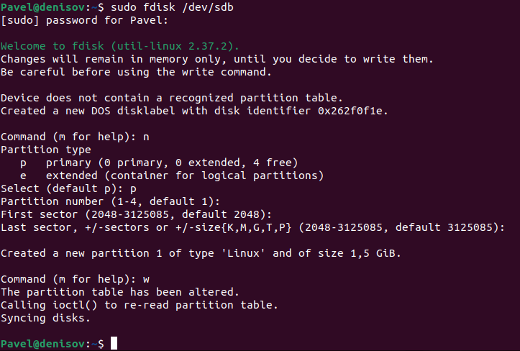

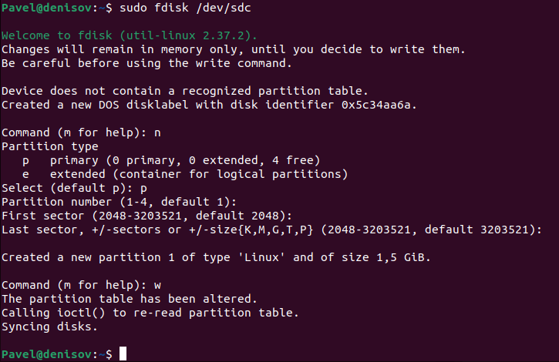

We check the success of the creation:

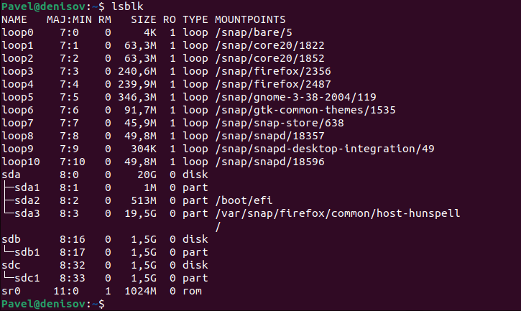

We create a RAID array on /dev/md0 based on the created partitions using mdadm and control its creation.

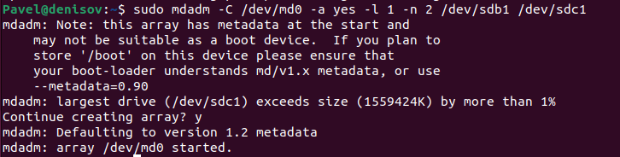

Create a file system based on RAID1:

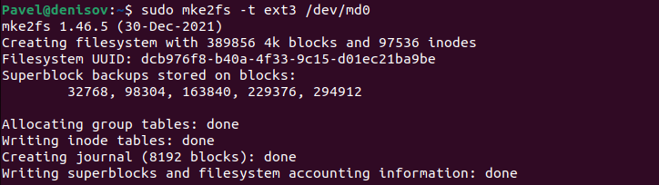

Mount the file system:

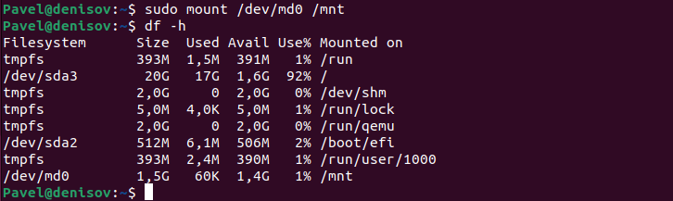

Save the created partitions to mount them automatically each time the system boots. In order to do that, get the UUID of the RAID1 array:



Then edit the /etc/fstab file containing the boot information and paste the UUID in there with corresponding options:

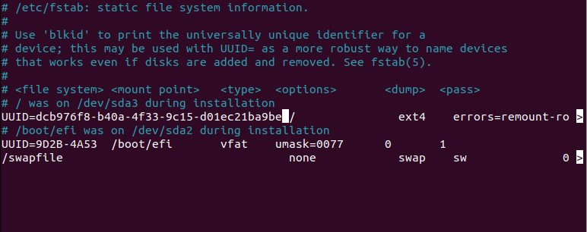

Test RAID1. In order to do that, add a test file in the /mnt directory as shown on the picture below:

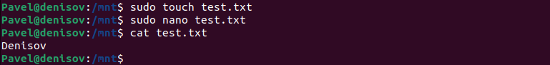

Remove sdc1 from RAID1:

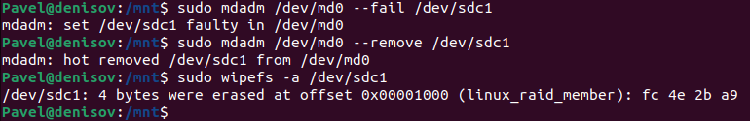

The file is available:

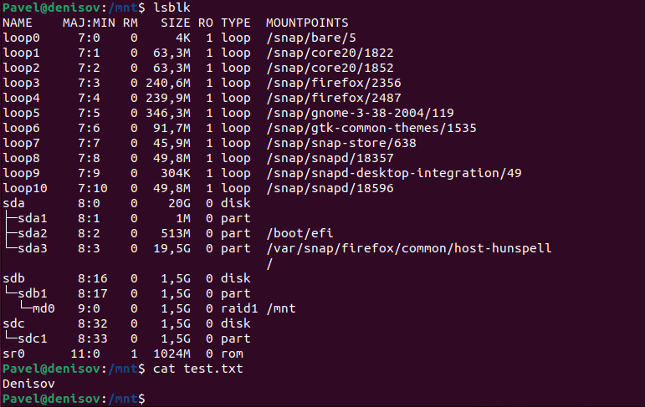

Adding new hdd and sync it to raid1:

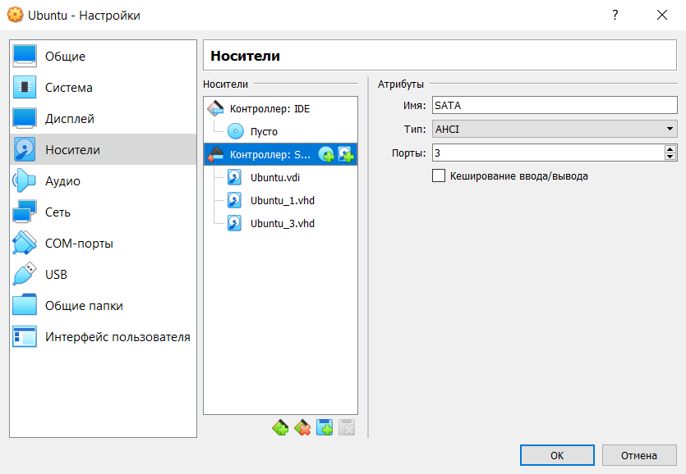

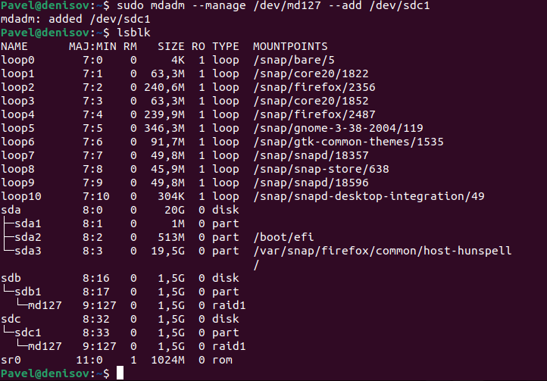

Check start docker:

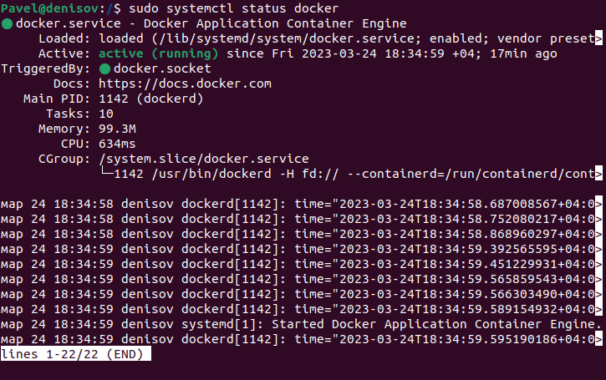

Check install minikube:

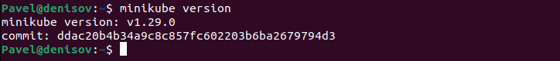

Start minikube:

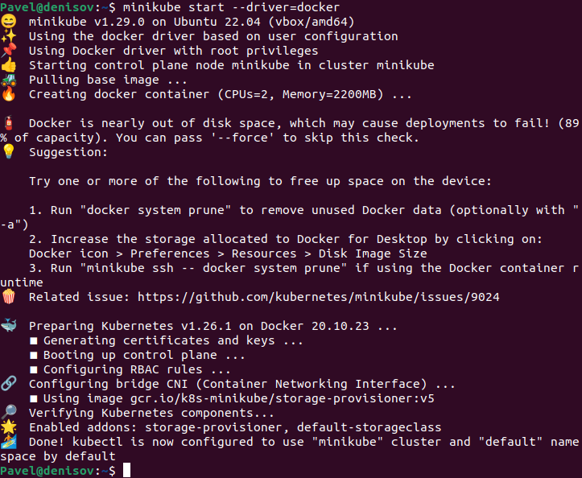

Minikube status:

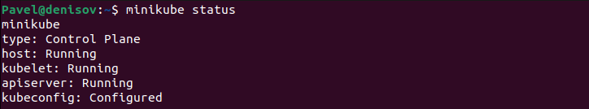

Add proxy:



Change port:



Open Dashboard:

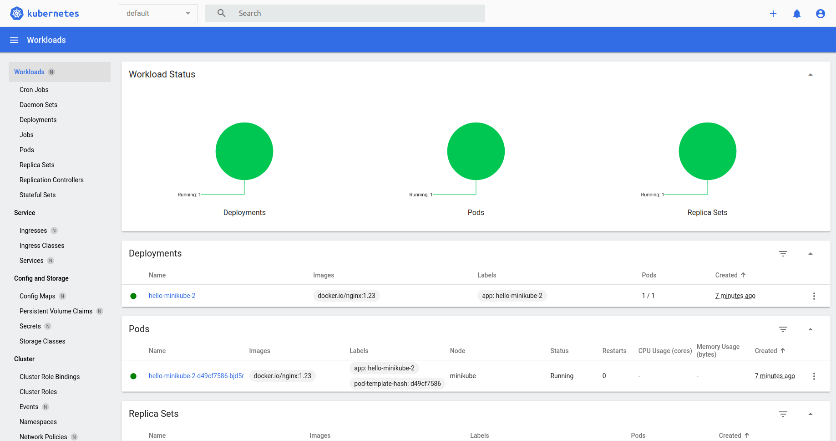

**CONCLUSION**

In the conclusion of the laboratory work, the basic utilities of the Ubuntu system studied for working with the file system, partitioning and creating RAID arrays; run minikube and deploy app; all steps completed successfully.